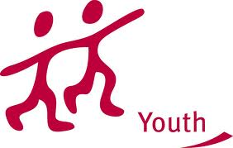


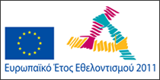

YOUTH EXCHANGE PROJECT
“EARTH”
GANGI, CICILY ITALY
05 - 12 March 2012
APPLICATION FORM

Deadline for applications : January 30th 2012

First name | LAST NAME

Full address

Private Phone + mobile phone | Private Email

Date of birth | Gender (F/M) | Nationality

Special needs (mobility, medical conditions, etc)
Special food requirements (vegetarian, allergies, etc)

Have you ever participated or been involved in a youth, environmental project? If so, please explain briefly what your project was about: theme, main activities, duration, publications, etc.

Please describe your motivation so to take part in this training course. Which, you think that will be your benefits (or Municipality’s benefits) from it?

What is your understanding of the non formal learning? Have you any previous experience?

Please explain what are your interest / motivation to participate in a local project? Would you participate as a volunteer?

Do you any concrete idea for a Local Environmental Project? Please describe it.

Please indicate your English skills (fluent, good, basic, poor)

Emergency Contact Person (in case of need) | Phone number
Full name Tel / email

Place | Date | Signature of applicant

