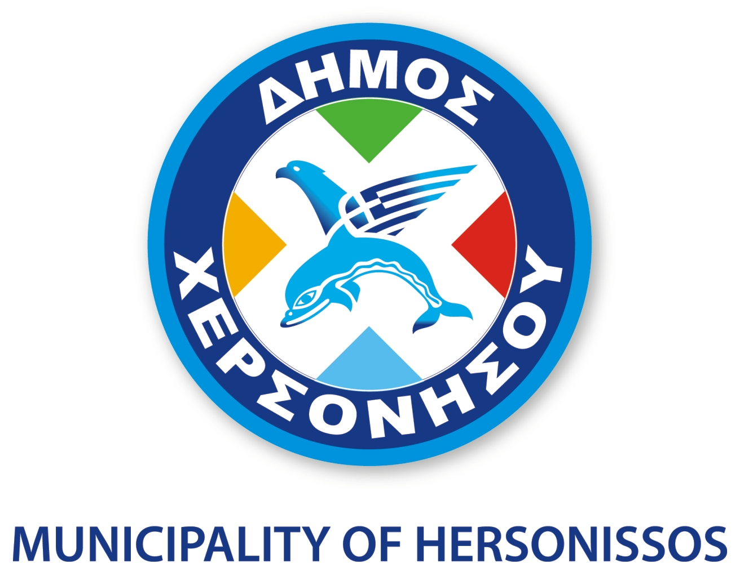

“Education of immigrants on the Greek language, Greek history and
Greek culture – Odysseus» at Hersonissos Municipality

The program “Education of immigrants on the Greek language, Greek history and Greek culture - Odysseus” addresses EU citizens and third country nationals who live in Greece and are at least 16 years old. The program is co - financed by Greece and the European Union in the context of the Operational Program “Education and Lifelong learning” of the Ministry of Education and Religious Affairs.

The main aim is: that learners will acquire the language skills as well as the social and cross-cultural capabilities which are necessary for the social integration and active participation of themselves and their families.
The educational program offers the following levels: A1 (125 hours), A2 (175 hours).

Lessons are free of charge and the weekly program is flexible according to the trainees needs. On completion of all educational programs, participants will be issued official Certificates of attendance.

For further information please contact us (until Monday 1st December 2014): Townhall, Malia: 2897340238, 2897340239 (Department of Employment)

